Abstract

This paper reports the results of a survey of evaluation and communication business requirement regarding the importance of citation counts in personnel decisions.



Evaluate and Communication Business Requirement

Mercy Salim Hong

18096@wic.edu.au

# Assessment –

# Research & Questioning

|  |  |  |  |
| --- | --- | --- | --- |
| Name of Student | Mercy Salim Hong | ID | 18096 |

Contents

[Assessment – 1](#_Toc81410982)

[Research & Questioning 1](#_Toc81410983)

[***Instructions:*** 1](#_Toc81410984)

[***Business Scenario*** 1](#_Toc81410985)

[***Task 1: Determine support areas*** 2](#_Toc81410986)

[***Task 2: Identify stakeholders*** 3](#_Toc81410987)

[***Task 3: Develop support procedures*** 4](#_Toc81410988)

[***Task 4: Assign Support Personnel*** 6](#_Toc81410989)

[***Task 5: Short Answer Questions*** 6](#_Toc81410990)

[***Task 6: Multiple Choice Questions*** 7](#_Toc81410991)

[Index 12](#_Toc81410992)

#### View My Web Support:

<https://mercyhong.github.io/ECBR180962022/>

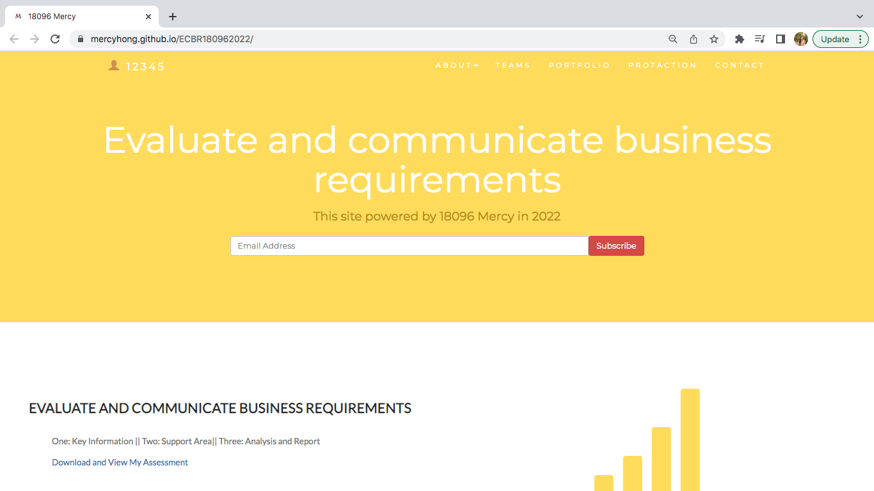

#### *Instructions:*

This assessment is to be completed individually. In this assessment you will be working through a number of written tasks based on case scenarios or research that relate directly to each element of competency for this cluster. Outlined below is information on how each of the tasks relates the element of competency covered.

Learn how to make Google Form: [https://www.youtube.com/watch?v=BtoOHhA3aPQ&t=4s](https://www.youtube.com/watch?v=BtoOHhA3aPQ&t=4s" \t "_blank)

Your tasks:

#### *Business Scenario*

D&K Books Pty Ltd is a bookstore owned by Mr. Dean Kerr. The business occupies two levels of an office building connected by escalators and lifts. D&K Books employs approximately six sales staff, one operation manager, two administrative officers, a bookkeeper and a marketing manager. They have an Ethernet network consisting of ten PCs (Intel I3 Desktop cloned), two switches, a router and three printers. They use the QuickBooks software to manage their entire business, including sales, inventory, ordering, accounts receivable, accounts payable, payroll and employee management. They also have two EFTPOS terminals one on each floor.

D&K Books has a Linux server that stores all of the data including the QuickBooks database. The server is backed up to tape regularly. They also have a website (hosted on an Australian ISP’s server, dynamic and static pages using asp.net) on which customers can browse the product catalogue and view current specials. They also lease a telephone system from Live Telecoms. The PABX (phone system) consists of a main switchboard and five remote phones with three incoming lines and a message-on-hold queue system.

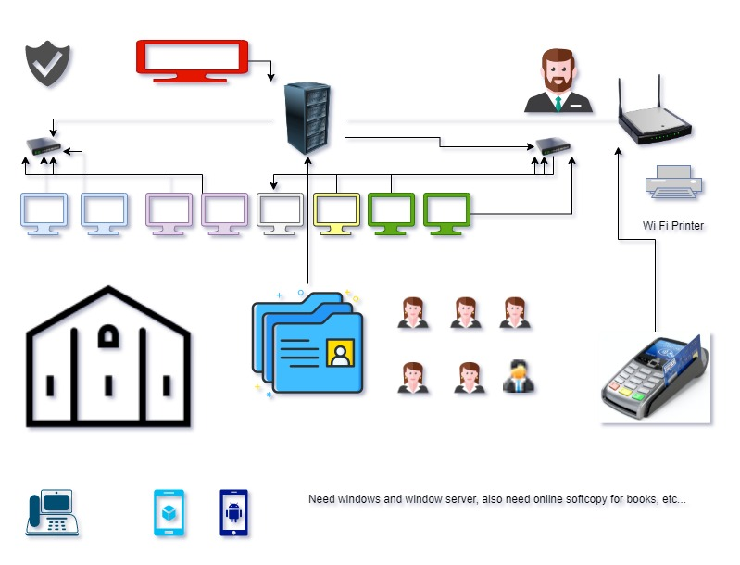

Good network system, you need setup at least:

|  |  |
| --- | --- |
| Hard ware | Software |
| Server X 1 | Window Server |
| Computer X 8 | Windows |
| Printer X 1 | SQL server |
| Telephone X 8 | Virus Protection |
| Modern X 2 | MS office |
| Network Cable | Eftpos machine More… |

#### *http://imapwebsolutions.com/wp-content/uploads/2014/07/linux-dedicated-server.pngTask 1: Determine support areas*

Identify information technology (HW and SW) and list the technology in use in D&K Books and consider the following:

* What sort of support does the technology require?
* Who is likely to provide this support?
* Does the support arrangement already exist?

Present your answer in a table such as the one below:

|  |  |  |  |  |
| --- | --- | --- | --- | --- |
| **Technology** | **Description** | **Support Required** | **Provider** | **Support Already exists? (Yes/No)** |
| QuickBooks Software | software that keeps track of all accounts, stock, GST, etc. | customisation, training, upgrades, bug fixes (patching), user support | Intuit Quickbooks [www.intuit.com.au](http://www.intuit.com.au) | No. |
| PC’s | Intel I3 Desktop cloned | upgrades, repairs, troubleshooting, maintenance, backup, customisation, network to link | Intel Core. | No. Need find one person to do this job |
| **Server**  IconExperience » V-Collection » Server Icon | Linux Server with tape backup  May need upgrade to hard disk backup | User account management, security policy implementation, home folder management, permissions management, backup and restore, operating system patching, software installation |  | No |
| EFTPOS | Easy to use | No need | shop | Yes |
| Telephone system | Low cost | Phone company | Telstra | Yes |
| Website | Low cost | Yes | Godaddy | Yes |
| Network | wireless | No external | No | No |

Please review my website:

<https://mercyhong.github.io/ECBR180962022/>

#### *Task 2: Identify stakeholders*

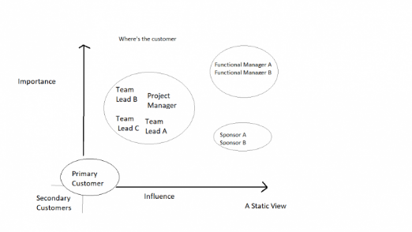 Identify stakeholders related in D&K Books system

All the staffs (the business owner, the relevant manager, the local workers and the remote workers) are stakeholders.

#### *Task 3: Develop support procedures*

1. Describe one positive and one negative experience you have had when seeking assistance from a telecommunication company, an ISP or a computer supplier. Your experience may be via telephone, email or even voice recognition.

|  |  |  |
| --- | --- | --- |
| Type | Positive | Negative |
| Telephone | Easy to get answer | Document provide |
| Email | Document, Picture, words or any media | Have to wait the team to reply |
| Go to company | Face to face get answer | Cost time and money on trip |
| Live Chat | Offers instant access to customer service staff | Chat boxes can often feel robotic and impersonal to some customers |

1. Using the experiences described above please answer the following questions.
   1. What support aspects were professional and/or unprofessional?
   2. How long did the support process take?
   3. Were the steps logical?
   4. Did they solve your problem?
   5. Was the call deflected to another area?

|  |  |  |
| --- | --- | --- |
| Items | professional | unprofessional |
| What support aspects | Friendly, Listening | Not what know your customer |
| How long | Very quick | Waiting and waiting |
| Steps logical | Yes | No |
| Solve | Good | Cannot |
| Another area | If has, need solve | If has, do not care |

Using feedback form or Google survey form.

Here is the very simple survey demo:

<https://docs.google.com/forms/d/e/1FAIpQLSegWq2q46qCHdT_sUU2qgGFxx1XO4NR_uFH-Ijh6G0AqacogA/viewform?usp=sf_link>

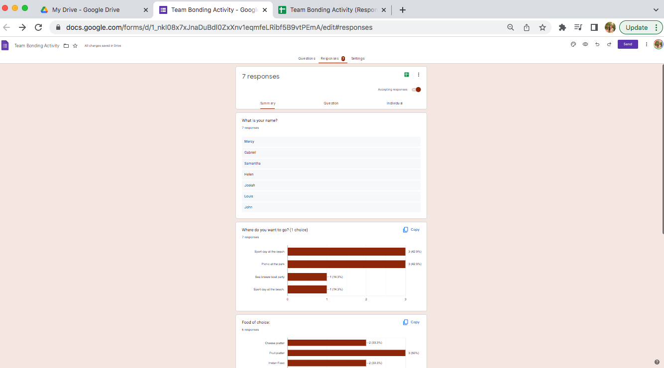

After I tested my friends, I could get nice response like:

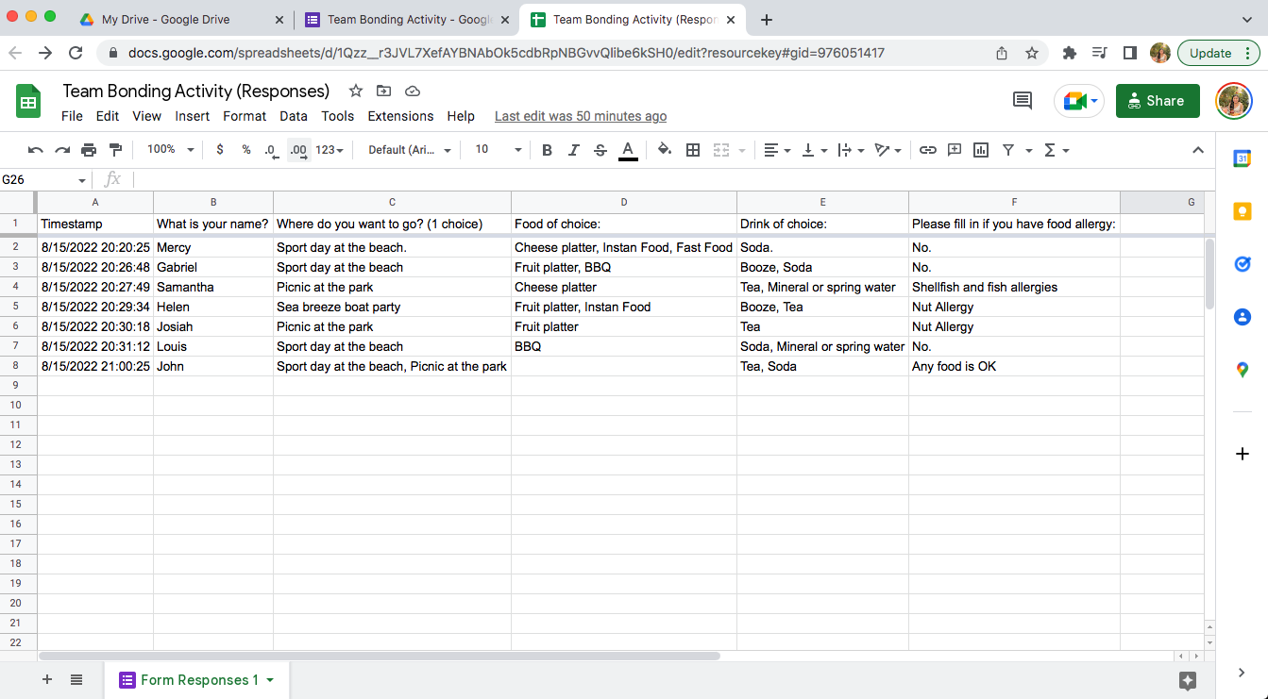

Or using link string:

<https://docs.google.com/spreadsheets/d/1Qzz__r3JVL7XefAYBNAbOk5cdbRpNBGvvQlibe6kSH0/edit?usp=sharing>

#### *Task 4: Assign Support Personnel*

Classify the following into soft skills and technical skills. Your answer should take the form of a table shown below.

|  |  |  |
| --- | --- | --- |
| **Skill** | **Soft skill** | **Technical skill** |
| A knowledge of Linux | X |  |
| The ability to work under pressure | X |  |
| The administration of Windows 2008 Server |  | X |
| The ability to formulate network and IT policies |  | X |
| The ability to write network documentation | X |  |
| The ability to give presentations | X |  |

#### *Task 5: Short Answer Questions*

1. 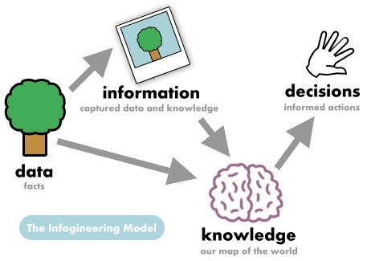Explain the relationship between data, information and knowledge.

Information is created when the data are structured, processed, and created to provide logical context and understanding. While knowledge is the context that we know.

1. What is quantitative data and how can you use it.

Quantitative data is the value of data that use the form of counts or numbers where the data has a value to see. We can use the data in research that focuses on quantifying the collection and analysis of data in the research.

1. What is qualitative data and how can you use it.

Qualitative data is the data that cannot be count by numbers or measured to express the information. We can collect the data by using questionnaires, interviews, and observation.

1. 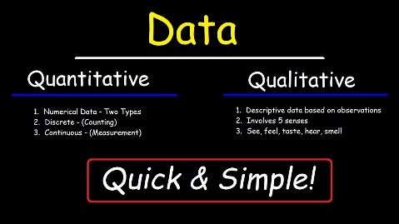Give an example of how quantitative and qualitative data can be used in conjunction with each other

Way to use both quantitative and qualitative data in conjunction with each other by conducting two tests, using closed-question surveys and web analytics. And you can also ask their opinions by using open-ended questions to know their opinions and values.

1. What sort of methods could you use to determine client requirements for a website design and key information sources?

Methods that we can use to determine client requirements for a website design and key information sources are:

* **Business Requirements**define the objectives and what problems the stakeholder intends to solve with the product.
* **User Requirements**describe how user expectations and how they will interact with the product.  Use the features, functions, and content described in your scenarios to develop your requirements. Your user scenarios should outline the tasks your users want to complete on your site.
* **Functional Requirements**provide details of how a product should behave and specify what is needed for development.
* **Quality-of-Service Requirements**detail what characteristics a product must maintain in order to maintain its effectiveness and any constraints.
* **Implementation Requirements**are used to detail changes in process, team roles, and migration from one system to another, etc.

1. Give some examples of client requirements for a website design

* Looks good
* 24 hours work
* Easy to update
* Upgrade is free
* Easy to use
* Clear product and service

#### *Task 6: Multiple Choice Questions*

1. Generally, how many points should a rating scale have?
   1. Five
   2. Four
   3. Ten
   4. Somewhere from 4 to 11 points

References: <https://www.voxco.com/blog/rating-scale/#:~:text=What%20is%20a%20Rating%20Scale,the%20qualitative%20and%20quantitative%20attributes>.

Reason: Numeric-rating scale uses numbers to identify the items in a scale. However, not all the numbers need to have an attribute attached to it.

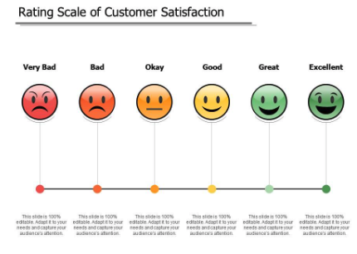

1. What is the problem(s) with this set of response categories to the question “What is your current age?” o 1-5 o 5-10 o 10-20 o 20-30 o 30-40
   1. The categories are not mutually exclusive
   2. The categories are not exhaustive
   3. Both a and b are problems
   4. There is no problem with the above set of response categories

Reason: the age response is not compatible and excludes the other ranges. The categories does not considering all elements or aspects.

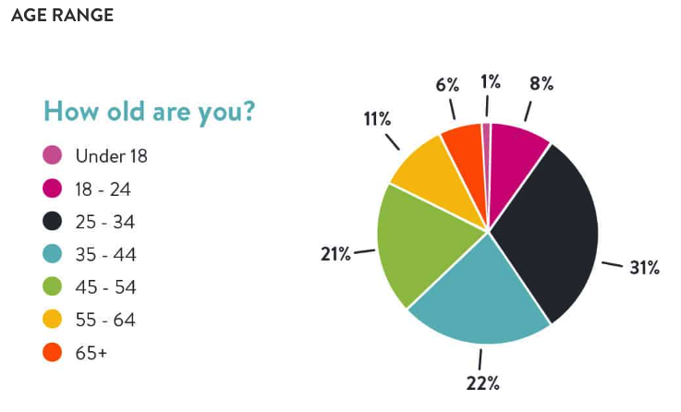

1. You should mix methods in a way that provides complementary strengths and no overlapping weaknesses. This is known as the fundamental principle of mixed research.

a) True

b) False

References: <http://edge.sagepub.com/sites/default/files/44402_17%20rq%206th%20ed.doc#:~:text=According%20to%20the%20fundamental%20principle,quantitative%20and%20qualitative%20research%20approaches>.

Reason: the researcher should use a mixture or combination of methods that has complementary strengths and non-overlapping weaknesses. This principle is important because it provides the researcher with logic for mixing quantitative and qualitative research approaches.

1. According to the text, questionnaires can address events and characteristics taking place when?
   1. In the past (retrospective questions)
   2. In the present (current time questions)
   3. In the future (prospective questions)
   4. All of the above

References: <https://www.fao.org/3/w3241e/w3241e05.htm>

Reason: That is the standard in questionnaire.

1. Which of the following are principles of questionnaire construction?
   1. Consider using multiple methods when measuring abstract constructs
   2. Use multiple items to measure abstract constructs
   3. Avoid double-barrelled questions
   4. All of the above
   5. Only b and c

References: <https://norstatgroup.com/blog/five-basic-principles-for-writing-good-questionnaires>

1. Which of these is not a method of data collection?
   1. Questionnaires
   2. Interviews
   3. Experiments
   4. Observations

References: <https://online.hbs.edu/blog/post/data-collection-methods>

Reason: Experiments is not part of data collection. Experiment is a procedure which can be repeated for indefinite times. It is also known as trial.

1. Secondary/existing data may include which of the following?
   1. Official documents
   2. Personal documents
   3. Archived research data
   4. All of the above

References: <https://campusirb.duke.edu/irb-policies/analysis-existing-data#:~:text=For%20the%20purposes%20of%20IRB,audio%2D%20or%20video%2Drecordings>.

Reason: It is for all the existing data collection purposes.

1. An item that directs participants to different follow-up questions depending on their response is called a \_\_\_\_\_\_\_\_\_\_\_\_.
   1. Response set
   2. Probe
   3. Semantic differential
   4. Contingency question

References: <https://home.csulb.edu/~msaintg/ppa696/696qstin.htm#:~:text=Contingency%20questions%20are%20questions%20that,or%20open%2Dended%20response%20options>.

Reason: Contingency questions are questions that are only to be answered by some subgroup(s) of respondents.

1. Which of the following terms best describes data that were originally collected at an earlier time by a different person for a different purpose?

a) Primary data

* 1. Secondary data
  2. Experimental data
  3. Field notes

Reference: <https://en.wikipedia.org/wiki/Secondary_data>

Reason: Secondary data is research data that has previously been gathered and can be accessed by researchers

1. Researchers use both open-ended and closed-ended questions to collect data. Which of the following statements is true?
   1. Open-ended questions directly provide quantitative data based on the researcher’s predetermined response categories
   2. Closed-ended questions provide quantitative data in the participant’s own words
   3. Open-ended questions provide qualitative data in the participant’s own words
   4. Closed-ended questions directly provide qualitative data in the participants’ own words

Reference: <https://www.nngroup.com/articles/open-ended-questions/#:~:text=Open%2Dended%20questions%20are%20questions,or%20All%20of%20the%20Above>).

1. Open-ended questions provide primarily \_\_\_\_\_\_ data.
   1. Confirmatory data
   2. Qualitative data
   3. Predictive data
   4. None of the above

Reference: <https://www.techtarget.com/searchcio/definition/qualitative-data#:~:text=Qualitative%20data%20is%20information%20that,graph%20databases%2C%20timelines%20and%20infographics>.

Reason: Qualitative data is important in determining the particular frequency of traits or characteristics.

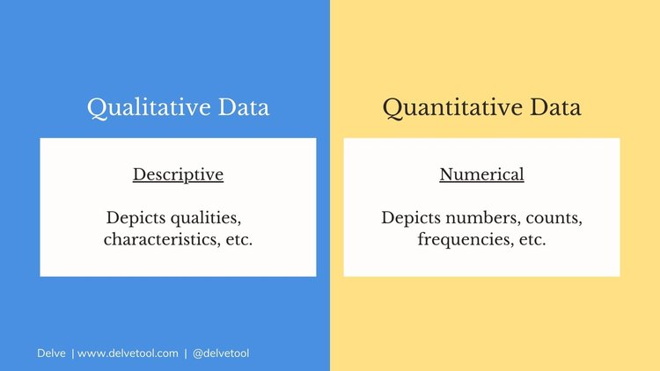

1. Which of the following is true concerning observation?
   1. It takes less time than self-report approaches
   2. It costs less money than self-report approaches
   3. It is often not possible to determine exactly why the people behave as they do
   4. All of the above

Reference: <https://faculty.washington.edu/wpratt/MEBI598/Methods/Collecting%20Data%20Through%20Observation.htm>

Reason: In direct observations, people know that you are watching them. The only danger is that they are reacting to you.

1. Qualitative observation is usually done for exploratory purposes; it is also called \_\_\_\_\_\_\_\_\_\_\_ observation.
   1. Structured
   2. Naturalistic
   3. Complete
   4. Probed

Reference: <https://www.verywellmind.com/what-is-naturalistic-observation-2795391>

Reason: a research method that involves observing subjects in their natural environment.



1. When constructing a questionnaire, it is important to do each of the following except \_\_\_\_\_\_.
   1. Use "leading" or "loaded" questions
   2. Use natural language
   3. Understand your research participants
   4. Pilot your test questionnaire

Reference: <https://www.fao.org/3/w3241e/w3241e05.htm>

Reason: So it is easier for people who fill up the questionnaire to understand what are they doing easily.

1. Another name for a Likert Scale is a(n):
   1. Interview protocol
   2. Event sampling
   3. Summated rating scale
   4. Ranking

Reference: <https://en.wikipedia.org/wiki/Likert_scale#:~:text=After%20the%20questionnaire%20is%20completed,are%20often%20called%20summative%20scales>.

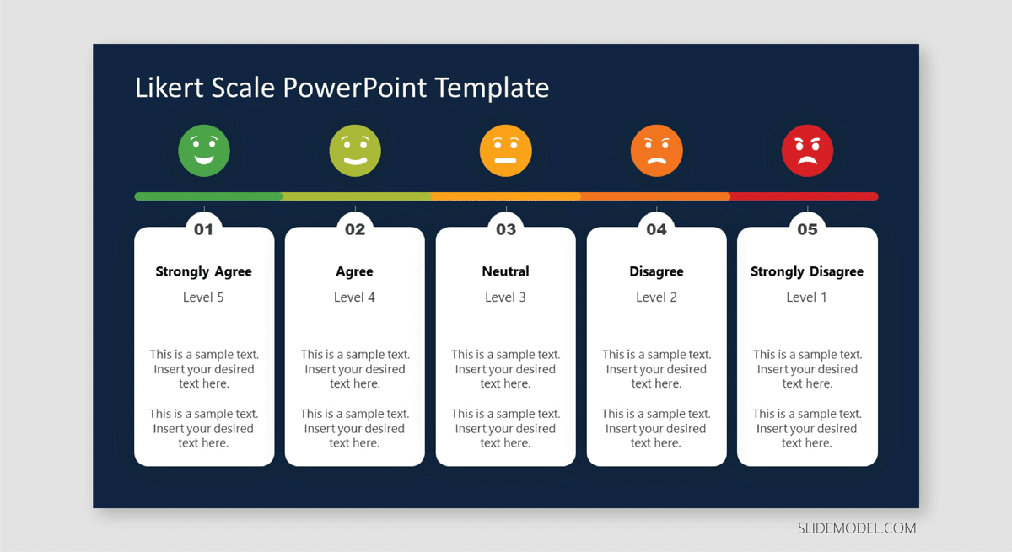

1. Which of the following is not one of the six major methods of data collection that are used by educational researchers?
   1. Observation
   2. Interviews
   3. Questionnaires
   4. Checklists

Reference: <https://callygood.medium.com/6-methods-of-data-collection-e946e993b930#:~:text=The%20most%20commonly%20used%20methods,documents%20and%20records%2C%20and%20experiments>.

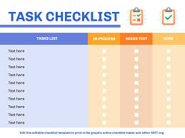

1. The type of interview in which the specific topics are decided in advance but the sequence and wording can be modified during the interview is called:

a) The interview guide approach

* 1. The informal conversational interview
  2. A closed quantitative interview
  3. The standardized open-ended interview

Reference: <https://managementhelp.org/businessresearch/interviews.htm#:~:text=General%20interview%20guide%20approach%20%E2%80%93%20the,getting%20information%20from%20the%20interviewee>.

1. Which one of the following in not a major method of data collection?
   1. Questionnaires
   2. Interviews
   3. Secondary data
   4. Focus groups
   5. All of the above are methods of data collection

Reference: <https://www.jotform.com/data-collection-methods/#:~:text=Since%20most%20research%20involves%20the,direct%20observations%2C%20and%20focus%20groups>.

1. A question during an interview such as “Why do you feel that way?” is known as

a) Probe

* 1. Filter question
  2. Response
  3. Pilot

Reference: <https://www.uoguelph.ca/hr/system/files/Probing%20Questions%20for%20Interviews.pdf>

Reason: Interview probes are follow-up questions or prompts used by the interviewer to guide the. candidate's description of situations or events or to provide elaboration of answers.

1. A census taker often collects data through which of the following?
   1. Standardized tests
   2. Interviews
   3. Secondary data
   4. Observations

Reference: <https://humansofdata.atlan.com/2018/02/how-when-collect-observational-data/#:~:text=In%20general%2C%20observation%20is%20a,in%20natural%20situations%20or%20settings>.

Reason: observation is a systematic way to collect data by observing people in natural situations or settings.

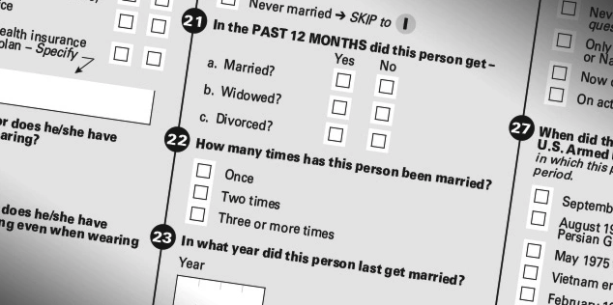

1. The researcher has secretly placed him or herself (as a member) in the group that is being studied. This researcher may be which of the following?

a) A complete participant

* 1. An observer-as-participant
  2. A participant-as-observer
  3. None of the above

Reference: <https://measuringu.com/observation-role/#:~:text=Complete%20Participant,fully%20interact%20with%20the%20researcher>.

Reason: This is a fully embedded researcher, almost like a spy. Here the observer fully engages with the participants and partakes in their activities. Participants aren't aware that observation and research is being conducted, even though they fully interact with the researcher.

1. Which of the following is not a major method of data collection?
   1. Questionnaires
   2. Focus groups
   3. Correlational method
   4. Secondary data

Reference: <https://www.jotform.com/data-collection-methods/#:~:text=Since%20most%20research%20involves%20the,direct%20observations%2C%20and%20focus%20groups>.

1. Which type of interview allows the questions to emerge from the immediate context or course of things?

a) Interview guide approach

* 1. Informal conversational interview
  2. Closed quantitative interview
  3. Standardized open-ended interview

Reference: <https://workbloom.com/interview/interview-types-best-way-approach-informal-interview>

1. When conducting an interview, asking "Anything else? What do you mean? Why do you feel that way?," etc, are all forms of:
   1. Contingency questions
   2. Probes
   3. Protocols
   4. Response categories

Reference: <https://www.uoguelph.ca/hr/system/files/Probing%20Questions%20for%20Interviews.pdf>

Reason: Interview probes are follow-up questions or prompts used by the interviewer to guide the. candidate's description of situations or events or to provide elaboration of answers.

1. When constructing a questionnaire, there are 15 principles to which you should adhere. Which of the following is not one of those principles?
   1. Do not use "leading" or "loaded" questions
   2. Avoid double-barrelled questions
   3. Avoid double negatives
   4. Avoid using multiple items to measure a single construct

Reference: <https://norstatgroup.com/blog/five-basic-principles-for-writing-good-questionnaires>

1. A customer-based Service Level Agreement structure includes:
   1. An SLA covering all Customer groups and all the services they use
   2. SLAs for each service that are Customer-focused and written in business language
   3. An SLA for each service type, covering all those Customer groups that use that Service
   4. An SLA with each individual Customer group, covering all of the services they use

Reference: <https://blog.masterofproject.com/3-types-sla/#:~:text=The%20second%20type%20of%20service,services%20used%20by%20this%20customer>.

1. Which of the following best describes the goal of Service Level Management?
   1. To maintain and improve IT service quality in line with business requirements
   2. To provide IT services at the lowest possible cost by agreeing with Customers their minimum requirements for service availability and ensuring performance does not exceed these targets
   3. To provide the highest possible level of service to Customers and continuously improve on this through ensuring all services operate at maximum availability
   4. To ensure that IT delivers the same standard of service at the least cost

Reference: <https://www.alaska.edu/files/oit/PinkSCAN_slm.pdf>

1. The process to implement SLAs comprises of the following activities in sequence:
   1. Draft SLAs, catalogue services, review underpinning contracts and OLAs, draft SLRs, negotiate, agree

SLAs

* 1. Draft SLAs, review underpinning contracts and OLAs, negotiate, catalogue services,
  2. Review underpinning contracts and OLAs, draft SLAs, catalogue services, negotiate, agree SLAs
  3. Catalogue services, establish SLRs, review underpinning contracts and OLAs, negotiate service levels, agree SLAs

Reference: <https://www.giva.com.au/wp/implementing-service-level-agreements-it-service-desk.cfm>

1. Which of the following is an example of a service level agreement (SLA) between an information systems support unit and a research unit in the laboratories of a large company?
   1. The maximum response time to get the system operational should it fail.
   2. The minimum ‘up-time’.
   3. The types of information that will be provided as standard.
   4. All of the above.

Reference: <https://www.bmc.com/blogs/sla-template-examples/>

1. Some organisations bring a degree of formality to the internal customer concept by encouraging (or requiring) different parts of the operation to agree on:

a) Internal service agreements

* 1. Service level agreements
  2. Formal provision agreements
  3. Delivery agreements

Reference: <https://www.cio.com/article/274740/outsourcing-sla-definitions-and-solutions.html>

Reason: A service-level agreement is a commitment between a service provider and a client. Particular aspects of the service – quality, availability, responsibilities – are agreed between the service provider and the service user.

## Index

B

bookstore 1

C

categories 6

closed-ended 7

D

data collection 9

L

Linux server 2

N

network 1

O

open-ended 7

S

Service Level 9

service level agreement 10

service quality 10

soft skills 5

support 3

T

technology 2

telecommunications 3